**NURBS Generation**

(Source = https://fr.wikipedia.org/wiki/NURBS)

**Curve Generation:**

NURBS curves are generated using this formula:

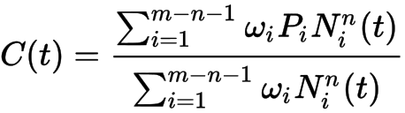

Where point control points are define by $P_{i}$ of weight $w_{i}$ with ***m*** the number of point and ***n*** the degrees of the curve

And $N_{i}^{n}$ is the coefficient computed by Cox-de-Boor algorithms as follow:

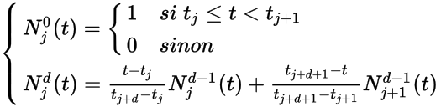

With $t_{j}$ are the knot belonging to the nodal vector and ***d*** the degree of the NURBS

If some knots $t_{j}$ are mingled, we have $\frac{0}{0}=0$

**Surface Generation:**

NURBS surfaces are generated using this formula:

